Create the Sample Web App in IIS with Port 80

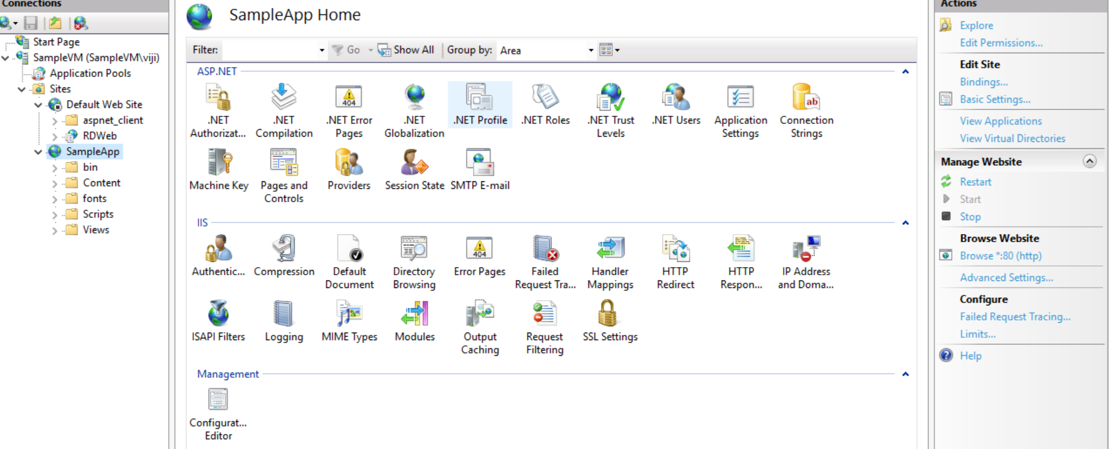

Check the Site Access in the following URL:

<https://migrate4.azurewebsites.net/>

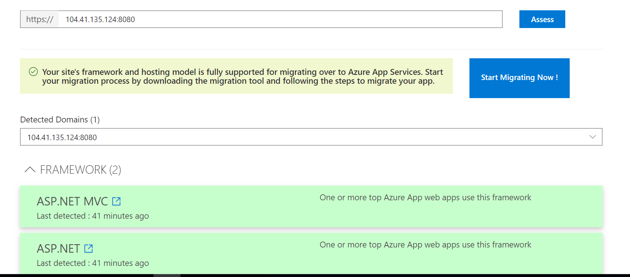

Get the Azure App Service Migration Assistant in the following Link:

<https://migrate4.azurewebsites.net/readiness>

Open the Migration App and Select Continue with Migrate sites and databases on local server to Azure

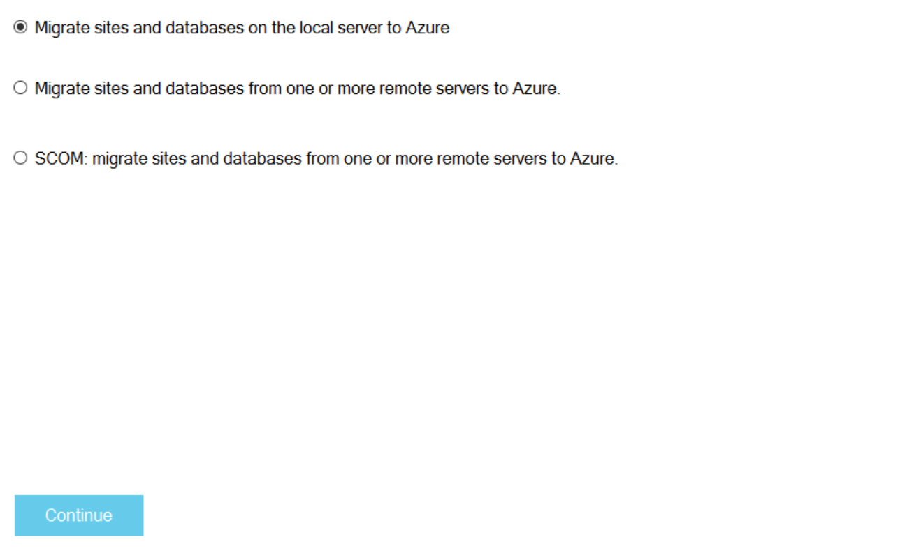

Select your web site and click next

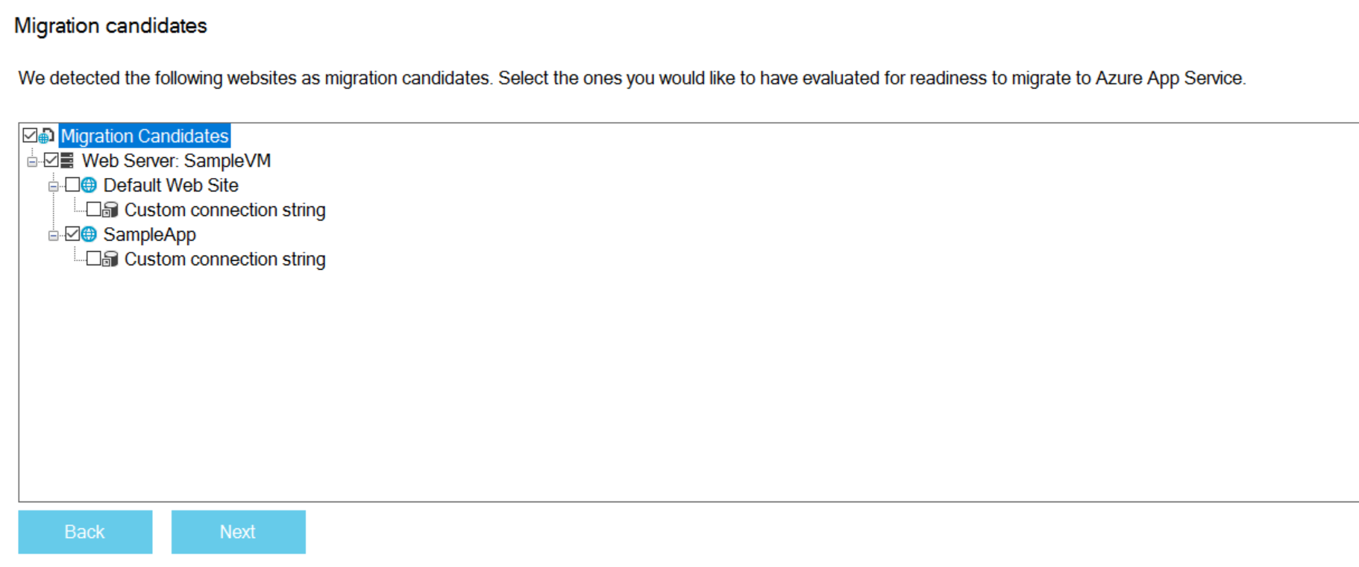

Select the Readiness Assessment

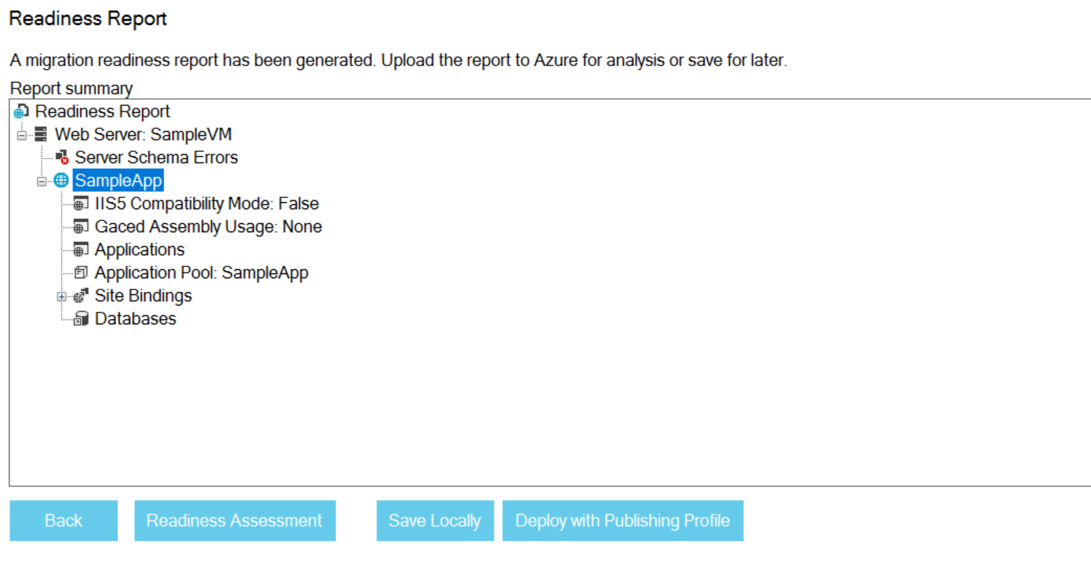

Click Begin Migration

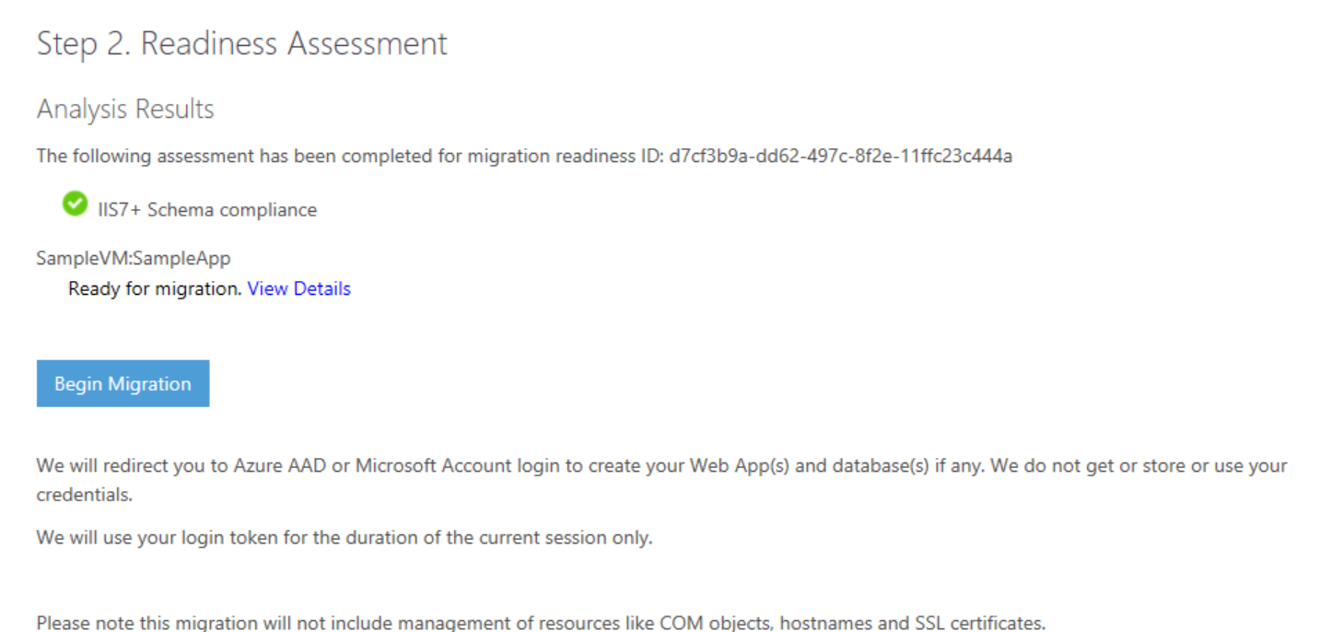

Add the Subscription, Resource group and Location

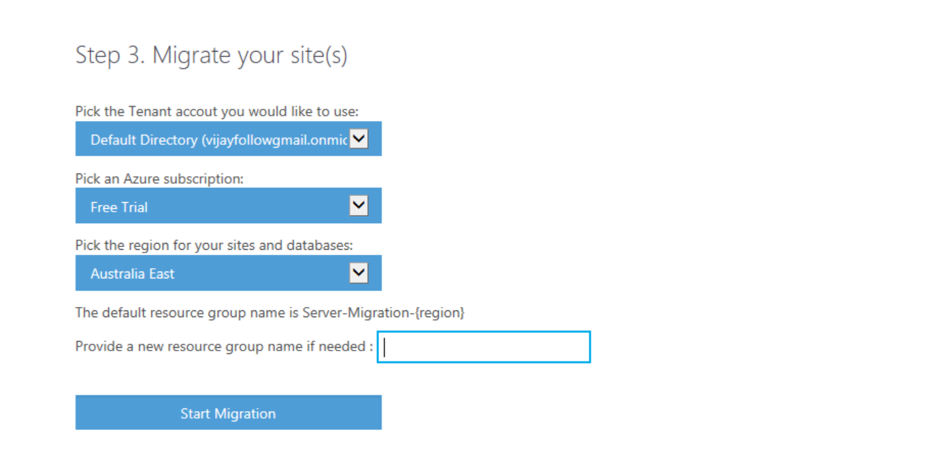

Select IIS Web Site and configure the Azure App and click create

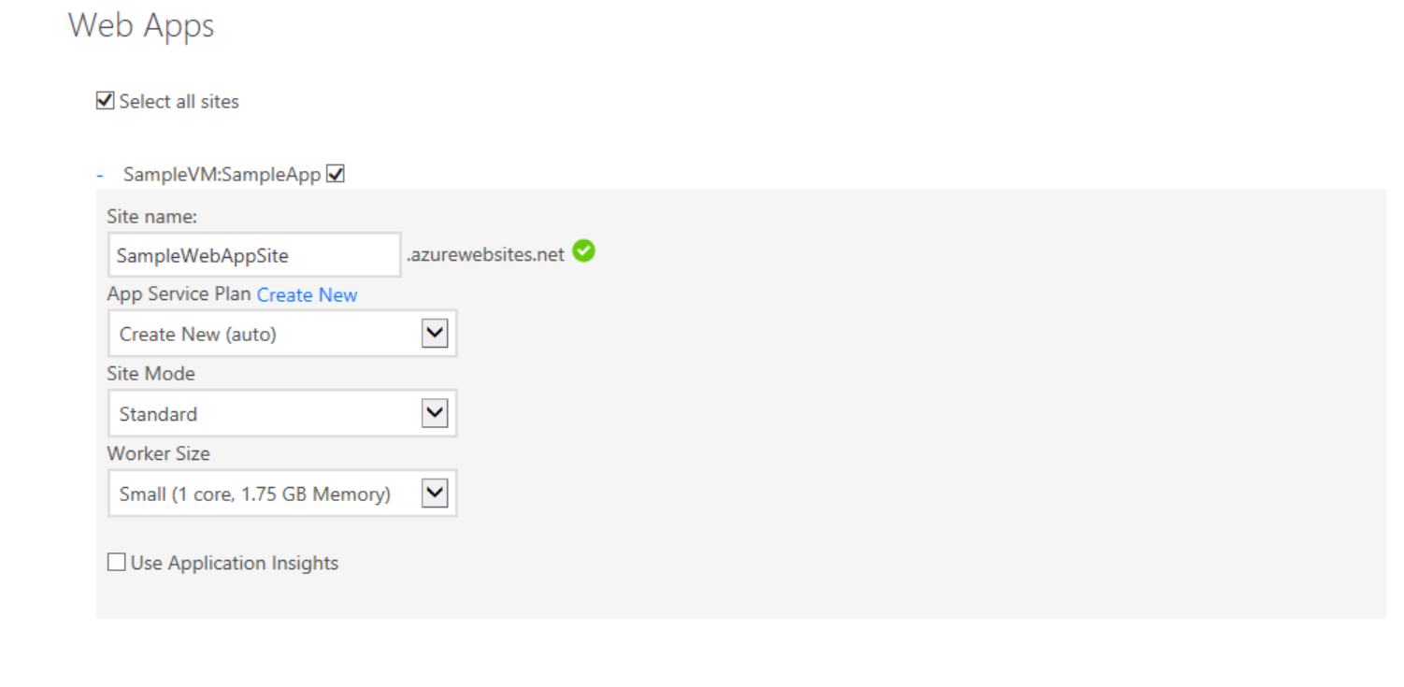

Click Begin Publish

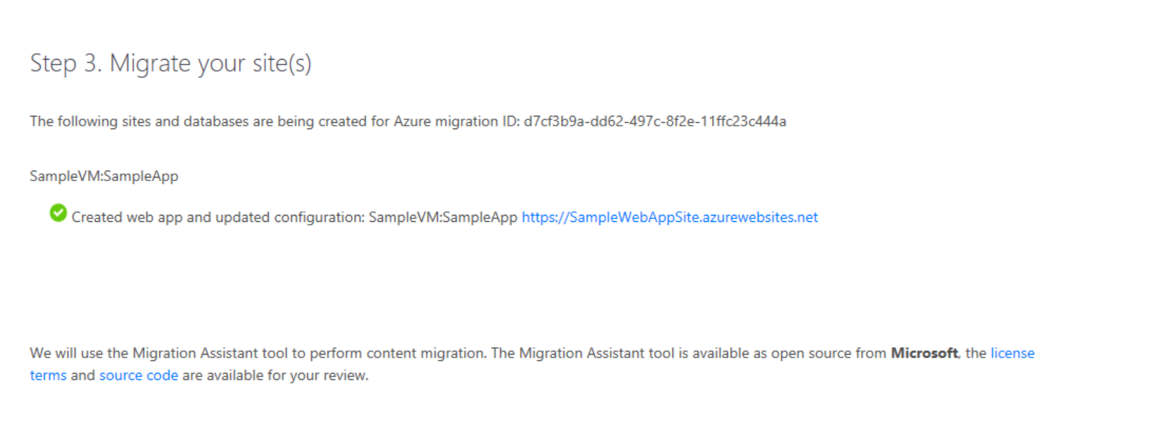

App Service Migration Assistant Successfully deployed into Azure Web App:

